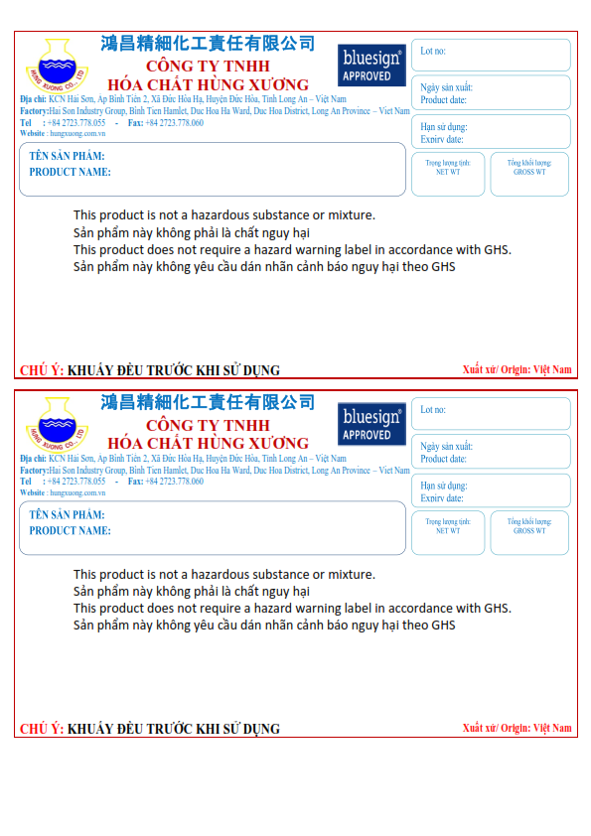

**08/04/2023**

**08/04/2023**

**126KG**

**120KG**

**126KG**

**120KG**

**HUNTEX HT-411P**

**08/10/2022**

**P081022SM7/1**

**08/10/2022**

**P081022SM7/1**

**HUNTEX HT-411P**